**Lesson21 Azure function with VS Code**

**Notes: -**

**1-on VS Code > extension tools we install Azure function and Azure account**

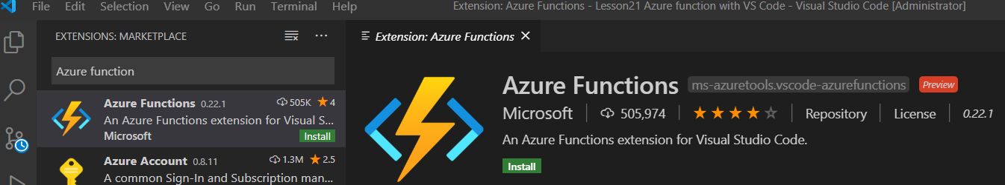

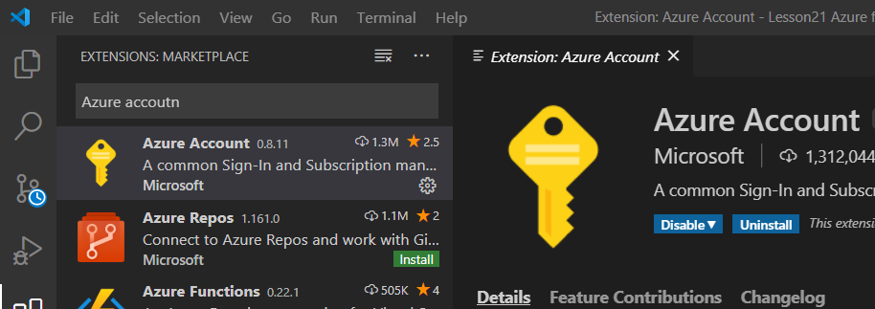

**2-we click on sign in Azure**

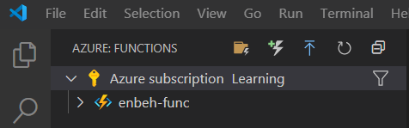

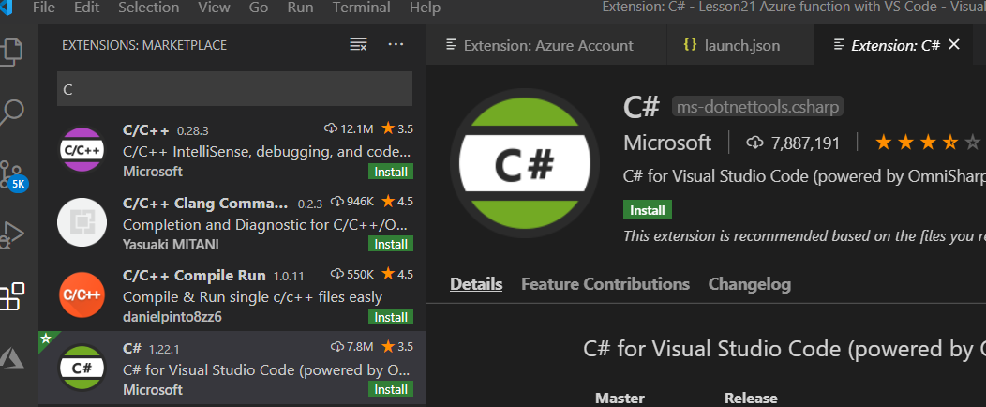

**3-we click on the plus (Add function) and select Http Triggers with select C# and type name as sampleFunTest**

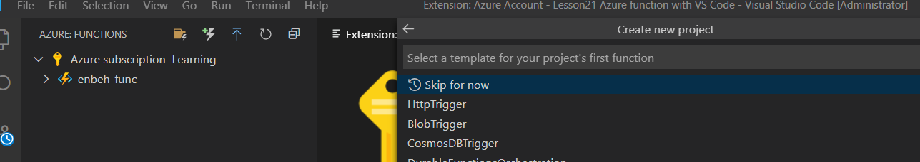

**4-we see the following code generated as below**

**using System;**

**using System.IO;**

**using System.Threading.Tasks;**

**using Microsoft.AspNetCore.Mvc;**

**using Microsoft.Azure.WebJobs;**

**using Microsoft.Azure.WebJobs.Extensions.Http;**

**using Microsoft.AspNetCore.Http;**

**using Microsoft.Extensions.Logging;**

**using Newtonsoft.Json;**

**namespace Company.Function{**

**public static class SampleFuncTest{**

**//we naming it as sampleFuncTest**

**[FunctionName("SampleFuncTest")]**

**//we provide the get and post request for the Run Method**

**//we declare 2 parameter request and log**

**public static async Task<IActionResult> Run(**

**[HttpTrigger(AuthorizationLevel.Function, "get", "post", Route = null)] HttpRequest req,**

**ILogger log){**

**log.LogInformation("C# HTTP trigger function processed a request.");**

**string name = req.Query["name"];**

**//we get the response and deserialize it to return as response**

**string requestBody = await new StreamReader(req.Body).ReadToEndAsync();**

**dynamic data = JsonConvert.DeserializeObject(requestBody);**

**name = name ?? data?.name;**

**string responseMessage = string.IsNullOrEmpty(name)**

**? "This HTTP triggered function executed successfully. Pass a name in the query string or in the request body for a personalized response."**

**: $"Hello, {name}. This HTTP triggered function executed successfully.";**

**return new OkObjectResult(responseMessage);}}}**

**5-runnign the project and take the URL and browse it , you see that it show the result**

**6-click on Deploy Button to upload the Azure function**